**Business Case**: A [business case](https://www.projectmanager.com/blog/how-to-write-a-business-case) outlines the **objectives**, **strategies**, and **projected outcomes**, providing [a clear roadmap](https://asana.com/resources/business-case) for navigating the complexities of the business landscape.

Four known tools for developing a business case are:

1. 5 Case Model (Strategic, Economic, Commercial, Financial, Management)
2. Model Canvas
3. Cost-Benefit Analysis
4. Scenario Planning

**Gap Analysis (As-is vs To-be)** – to identify areas for improvement across various dimensions of organizational effectiveness and develop targeted interventions to address these challenges.

The Nadler-Tushman Congruence Model

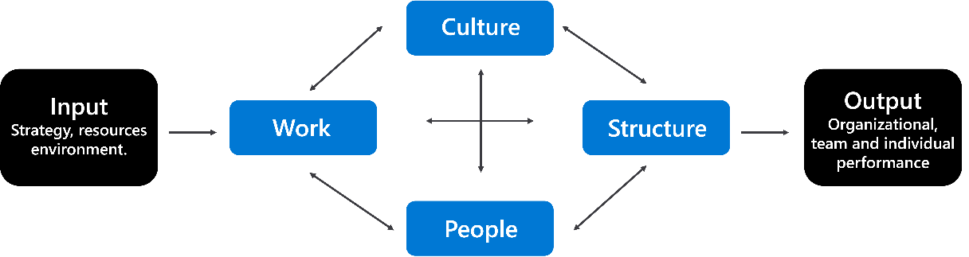

FEEDBACK

THROUGHPUTS

(Process)

OUTPUT

INPUT

The McKinsey 7S Framework

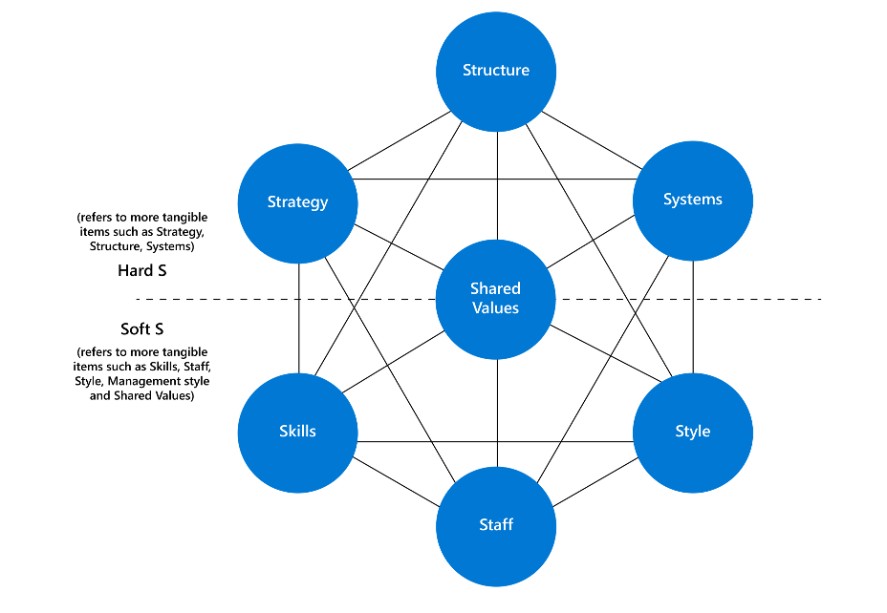

**Capability Analysis** – conducting capability assessment and constructing capability map. Define core capability, which is the top level, then breakdown into second level. Shouldn’t have more than 3 levels.

**Business Case Document –** aims to analyze various solutions to a business problem and justify the chosen solution based on factors like cost, benefits, and feasibility.

**Impact Analysis** - a way to anticipate how changes affect people, organizations, processes, information, and technology (POPIT). This is to avoid any disaster during the implementation.

**Risk Analysis** – can be quantitative (e.g. 2D or Monte Carlo simulation) or qualitative (e.g. SWIFT or Bowtie, Delphi technique). Quantitative provides numbers and qualitative provides deep understanding. Risk should be organized into their categories based on its origin, e.g., Strategic risk, Operational risk, Financial risk, Compliance.

After risk analysis, risk mitigation strategies should be implemented. However, risk mitigation strategies are not part of risk analysis.

**Scenario Analysis** – creating different scenarios to uncover the user needs and finally optimizing the best solution. A detective toolkit. It is used to **explore** and **define** potential situations. It results in:

1. Needs Clarification
2. Edge Cases Identification
3. Requirement Validation
4. Enhanced Communication
5. Risks Mitigation

It includes scenario description, process steps and observations, then document the requirements.

Visualization – for example, Mind map and Fishbone diagram (uncover underlying root causes).

**Critical Success Factor Analysis** – involves identifying the factors crucial for the success of a project or business operation. By identifying the essential areas that must be achieved for an organization or project to fulfill its mission and goals, CSF analysis provides a clear framework for prioritizing efforts and resources. Focus attention on the most important elements that will determine project success.

**Business Activity Models (BAM)** - an analysis technique to capture a high-level overview of the business activities that take place within an organization. BAM focuses on what the company does rather than how it does it or who does it. Describes five types of business activities and the dependencies between them.

*Ps – Planning activities*

*Es – Enabling activities (budget, resources, and technology to complete the work is available)*

*Ds – Doing activities. This is the execution plan with available resources.*

*Ms – Monitoring activities. Track to ensure the alignment with the plans and identify deviations.*

*Cs – Control activities. Correct/optimize Ps, Es and Ds based on data from Ms.*

**Business Process Model (BPM)** – shows how different parts of a business work together. Useful in visualizing future states or to-be states and performing gap analysis.

**Data models** – define exactly what data and organization needs to collect, store, and how to organize it.

**Requirement Engineering** – **RE** framework to capture requirements

Step 1: Elicitation – identify stakeholders, needs, expectations and requirements.

Step 2: Analysis – involves sifting through the gathered data to identify common themes, identify any ambiguities, conflicts, or gaps and prioritize requirements.

Step 3: Validation – accuracy and feasibility of collected requirements.

Step 4: Documentation – involves creating detailed requirement specifications that outline each feature's purpose, scope, and acceptance criteria.

Step 5: Management - an ongoing process that continues throughout the project life cycle. It involves monitoring the requirements and adjusting them as needed to ensure they are met.

**Iteration** in RE – cycles of development work within the agile methodology, typically lasting two weeks. Each iteration involves planning, developing, testing and reviewing.

**Increment** in RE – delivers a complete and functional part of the app. For example, in mobile app development, the first increment is user authentication and profile management, and so on.

In practice, combining incremental and iterative development can lead to a robust and adaptive process. Start with incremental development to build a solid foundation and then use iterative development to refine and perfect your product.

**Functional** Requirements – “doing” part of the system, what business needs and what system will do.

**Non-Functional** Requirements – “being” part of the system, how system should perform. Usually from technical aspect of the system. Usability, scalability, interoperability and portability (web apps, mobile).

**INVEST** – tool for evaluating each requirement

I – Independent (Is the requirement independent or rely on another requirement)

N – Negotiable (Can the requirement be negotiable)

V – Valuable (Give value to the stakeholders)

E – Estimate (Can the requirement be estimated?)

S – Small (More manageable and easier to track, more accurate on estimate)

T – Testable (Should be able to test)

**Requirement Validation** – Stakeholders has the final say on confirmation of the requirement.

User Story – The three Cs. Card, Conversation and Confirmation.

Card – As a … I want … so that …

Conversation – include development team in the conversation with stakeholders

Confirmation – acceptance criteria, Given I’m in … situations, When I do … Then… this happens.

UML – two main groups, behavioral and structural. [UML Class Diagrams - Graphical Notation Reference](https://www.uml-diagrams.org/class-reference.html) Behavioral diagrams show what happens within a system and how it engages with users and related systems. Structural diagrams illustrate the elements and relationships of a system.